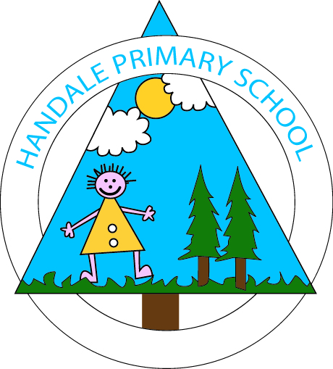
Handale Primary
School

Early Years Curriculum

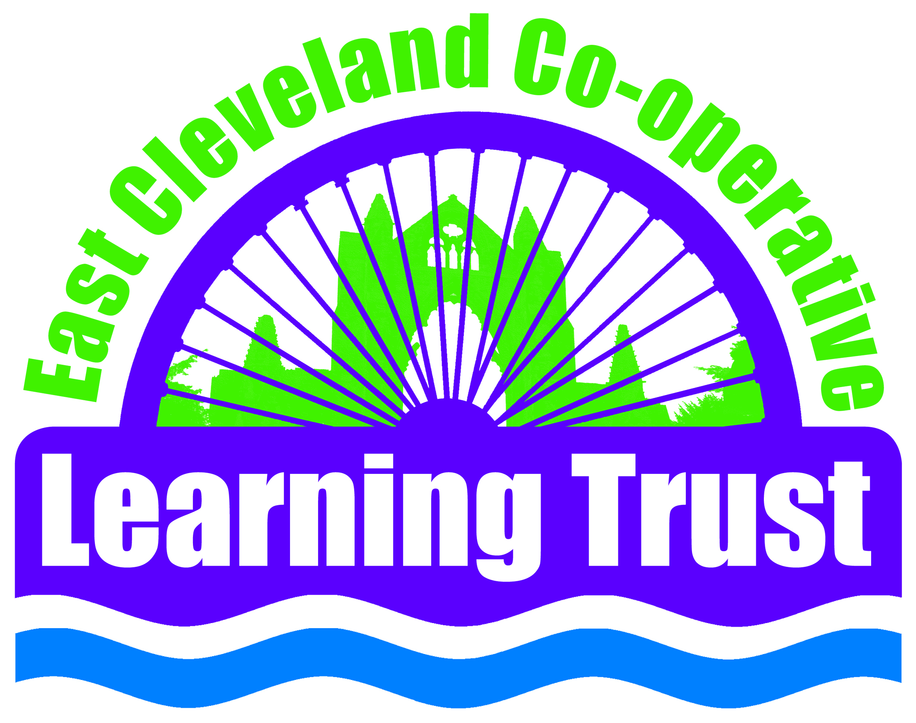
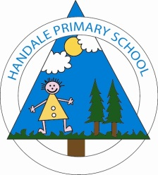

Handale Primary School Early Years Foundation Stage

At Handale Primary School we are committed to providing a high quality early years education which gives children a secure and confident start to their school life and nurtures a lifelong love of learning. This is achieved by developing childrens’ interests which influence the flow of our curriculum and supports children’s own choices and allows them to be individuals. Skilful practitioners scaffold children’s learning enabling them to develop along their own unique learning journey.

We believe:

“Learning is your students’ journey. Let them navigate. Push them to explore. Watch them discover. Encourage their questions. Allow them to struggle. Support their thinking. LET THEM FLY!”

(Krissy Venosdale)

Early Reading
Communication and Language:
This involves giving children opportunities to speak and listen in a range of situations and to develop their confidence and skills in expressing themselves.
ELG - Listening and attention: *Children listen attentively in a range of situations; *They listen to stories, accurately anticipating key events and respond to what they hear with relevant comments, questions or actions; *They give their attention to what others say and respond appropriately, while engaged in another activity.
ELG - Understanding: *Children follow instructions involving several ideas or actions; *They answer ‘how’ and ‘why’ questions about their experiences and in response to stories or events.
ELG - Speaking: *Children express themselves effectively, showing awareness of listeners’ needs; *They use past, present and future forms accurately when talking about events that have happened or are to happen in the future; *They develop their own narratives and explanations by connecting ideas or events.
Reading:
This involves encouraging children to read, through listening to others reading, and being encouraged to begin to read and themselves. Children must be given access to a wide range of reading materials such as books, poems, to ignite their interest.
ELG - Reading: *Children read and understand simple sentences; *They use phonic knowledge to decode regular words and read them aloud accurately; *They also read some common irregular words; *They demonstrate understanding when talking with others about what they have read.

On entry to Pre-nursery:
- Shows interest in play with sounds, songs and rhymes
- Shows concentration for a short period of time
- Understands a simple sentence
- Can match a range of objects to names
- Beginning to ask simple questions
- Beginning to sing favourite songs and rhymes
- Enjoys sharing a story with an adult
On entry to Nursery:
- Listen to others one to one and in small groups
- Listen to instructions and begin to follow directions
- Responds to a simple question
- Responds to a simple instruction
- Holds a conversation
- Uses a variety of questions
- Requests favourite songs or stories
- Shows interest in illustrations and print in books and print in the environment
Mid-Nursery 2:
- Listens and concentrates in a large group
- Listens and responds to known rhymes and songs
- Understands ‘why’ and ‘how’ questions
- Uses talk to connect ideas, explain what is happening and anticipate what might happen next, recall and relive past experiences
- Recognises own name
- Understands that books are special and looks at them independently. Handles books carefully, holding the correct way up and turning pages.
On entry to Reception:
- Is able to follow directions
- Joins in with repeated phrases during stories
- Listens and responds to ideas expressed by others in conversation, discussion and play
- Uses vocabulary focused on objects and people that are of particular importance to them
- Begins to extends vocabulary through exploring the meaning and sounds of words
- Listens to stories with increasing attention and recall
- Anticipates key events and phrases in rhymes in stories
Mid- Reception:
- Concentrates and maintains appropriate attention for a sustained period of time
- Is able to say what happens next in a known story and to know some key features of stories
- Understands instructions containing sequence words e.g. first, after, last. Follows instructions involving several ideas or actions.
- Uses talk to organise, sequence and clarify thinking, ideas, feelings and events.
- Can segment the sounds in simple words and blend them together and knows which letters represent some of them. Reads some irregular words.

Early Writing
Physical development
This involves providing opportunities for children to be active and interactive, and to develop their co-ordination, control, and movement.
ELG - Moving and handling: *Children show good control and co-ordination in large and small movements; *They move confidently in a range of ways, safely negotiating space; *They handle equipment and tools effectively, including pencils for writing.
Literacy This involves encouraging children to write, through being encouraged to begin to write themselves. Children must be given access to a wide range of written materials to ignite their interest.
ELG - Writing: *Children use their phonic knowledge to write words in ways which match their spoken sounds; *They also write some irregular common words; *They write simple sentences which can be read by themselves and others. Some words are spelt correctly and others are phonetically plausible.

On entry to Pre-nursery:
- Shows some control in holding and using a range of resources
- Makes connections between actions and the marks being made

On entry to Nursery:
- Uses pincer movement to pick up a range of objects
- Moves with confidence during indoor and outdoor activities
- Takes part in fine motor activities demonstrating some control and confidence
- Distinguishes between the different marks they make

Mid-Nursery 2:
- Shows increased control when using one-handed tools and equipment
- Moves skilfully and negotiates space successfully
- Recognises some letters from their name
- Uses marks to represent letters

On entry to Reception:
- Shows control in using simple tools when completing a task
- Draws lines and circles using gross motor movements. Begins to use anticlockwise movement and retrace vertical lines
- Uses some clearly identifiable letters to communicate meaning

Mid- Reception:
- Holds a pencil effectively
- Forms recognisable letters, mostly formed correctly
- Writes labels and captions
- Beginning to use full stops and capital letters in the correct place

Mathematics
Mathematics
This involves providing children with opportunities to: • practise and improve their skills in counting numbers, calculating simple addition and subtraction problems • describe shapes, spaces, and measures
ELG - Numbers: *Children count reliably with numbers from 1 to 20, place them in order and say which number is one more or one less than a given number; *Using quantities and objects, they add and subtract 2 single-digit numbers and count on or back to find the answer; *They solve problems, including doubling, halving and sharing
ELG - Shape, space and measures: *Children use everyday language to talk about size, weight, capacity, position, distance, time and money to compare quantities and objects and to solve problems; *They recognise, create and describe patterns; *They explore characteristics of everyday objects and shapes and use mathematical language to describe them.

On entry to Pre-nursery:
- Listen to and enjoy counting rhymes and songs
- Uses number names within their play
- Fills and empties a variety of containers
- Uses a range of objects to create their own simple structures and arrangements

On entry to Nursery:
- Uses some number names accurately in play
- Uses some mathematical language appropriate to task
- Shows an interest in shape and space by playing with shapes or making arrangement with objects
- Beginning to categorise objects according to properties

Mid-Nursery 2:
- Beginning to represent numbers using fingers, pictures or objects
- Can accurately count up to 5 objects
- Attempts to match objects and numerals
- Shows interest in shape by sustained construction activity

On entry to Reception:
- Shows an interest in representing numbers
- Recognises some numerals of personal significance
- Counts up to 3 or 4 objects by saying one number name for each item
- Beginning to talk about the shapes of everyday objects
- Uses shapes appropriately for tasks

Mid- Reception:
- Says the number that is one more than a given number up to 20
- Counts reliably 10 objects
- Finds the total number of items in two group by counting all of them
- Records, using marks that they can interpret and explain
- Uses some correct names for 3D solid shapes and 2D flat shapes
- Create repeating patterns and recognise patterns in shape

Personal, Social and Emotional Development

Personal, social and emotional development
This involves helping children to: • develop a positive sense of themselves and others • form positive relationships and develop respect for others • develop social skills and learn how to manage their feelings • understand appropriate behaviour in groups • have confidence in their own abilities
ELG - Self-confidence and self-awareness: *Children are confident about trying new activities, and say why they like some activities more than others; *They are confident speaking in a familiar group, will talk about their ideas, and will choose the resources they need for their chosen activities; *They say when they do or do not need help.
ELG - Managing feelings and behaviour: *Children talk about how they and others show feelings, talk about their own and others’ behaviour and its consequences, and know that some behaviour is unacceptable; *They work as part of a group or class, and understand and follow the rules; *They adjust their behaviour to different situations, and take changes of routine in their stride.
ELG - Making relationships: *Children play co-operatively, taking turns with others; *They take account of one another’s ideas about how to organise their activity; *They show sensitivity to others’ needs and feelings, and form positive relationships with adults and other children
Physical development
Children must be helped to understand the importance of physical activity, and to make healthy choices in relation to food.
ELG - Health and self-care: *Children know the importance for good health of physical exercise and a healthy diet, and talk about ways to keep healthy and safe; *They manage their own basic hygiene and personal needs successfully, including dressing and going to the toilet independently

On entry to Pre-nursery:
- Seeks comfort from familiar adults when needed
- Confident to explore new environments with support
- Responds to a few appropriate boundaries
- Shows interest in the activities of others
- Plays cooperatively with a familiar adult
- Shows a desire to help with dressing/undressing and hygiene routines
On entry to Nursery:
- Can select and use activities and resources
- Beginning to talk to other children when playing
- Shows understanding and cooperates with some boundaries and routines
- Beginning to play in a group alongside other children
- Independently accesses the toilet
- Beginning to help with own clothing and hygiene routines
Mid-Nursery 2:
- Enjoy the responsibility of carrying out small tasks
- Confident to talk to other children and a familiar adult in a small group
- Knows how to behave in a specific situation
- Beginning to negotiate and solve problems without aggression
- Happy to be part of a group and play together
- Usually dry and clean during the day
- Dresses themselves with minimal support
On entry to Reception:
- Shows confidence in asking adults for help
- Are able to cope with delay in having their needs met
- Can adapt behaviour to different events, social situations and changes in routine
- Follows rules in the classroom
- Takes turns and shares
- Demonstrates friendly behaviour
- Shows understanding of the need for safety when tackling new challenges, and considers and manages some risks
Mid- Reception:
- Confident to speak to others about own needs, wants, interests and opinions
- Becomes engrossed in activities for a sustained time period
- Uses growing vocabulary to resolve situations
- Tries to comfort other children when they realise they have upset them
- Takes steps to resolve conflicts with other children
- Shows an understanding that good practices with regard to exercise, eating, sleeping and hygiene can contribute to good health

Understanding The World

Understanding the world
This involves guiding children to: make sense of their physical world and their community through opportunities to explore, observe and find out about people, places, technology and the environment
ELG-People and communities: *Children talk about past and present events in their own lives and in the lives of family members. *They know that other children don’t always enjoy the same things, and are sensitive to this. *They know about similarities and differences between themselves and others, and among families, communities and traditions.
ELG-The world: *Children know about similarities and differences in relation to places, objects, materials and living things. *They talk about the features of their own immediate environment and how environments might vary from one another. *They make observations of animals and plants and explain why some things occur, and talk about changes.
ELG-Technology: *Children recognise that a range of technology is used in places such as homes and schools. *They select and use technology for particular purposes.

On entry to Pre-nursery:
- In pretend play, imitates everyday actions and events from own family and cultural background
- Enjoys playing with small-world models such as a farm, a garage or a train track
- Operates mechanical toys e.g. turns the knob on a wind-up toy or pulls back on a friction car

On entry to Nursery:
- Beginning to have their own friends
- Can talk about some of the things they have observed such as plants, animals, natural and found objects
- Shows an interest with technological toys or real objects

Mid-Nursery 2:
- Remembers and talks about significant events in their own experience
- Talks about why things happen and how things work
- Knows how to operate simple equipment e.g. turns on CD player and uses remote control

On entry to Reception:
- Knows some of the things that make them unique, and can talk about some of the similarities and differences in relation to friends and family
- Shows care and concern for living things and the environment
- Can swipe or click on a digital device to achieve an outcome

Mid- Reception:
- Talk about the past, in relation to their own life and the lives of family members
- Observe and talk about the environment, the natural world and growth and changes
- Use a device to support learning and explain what they are doing

Expressive Arts and Design

Expressive Arts and Design
This involves: enabling children to explore and play with a wide range of media and materials, as well as providing opportunities and encouragement for sharing their thoughts, ideas and feelings through a variety of activities in art, music, movement, dance, role-play, and design and technology
ELG - Exploring and using media and materials: *Children sing songs, make music and dance, and experiment with ways of changing them. *They safely use and explore a variety of materials, tools and techniques, experimenting with colour, design, texture, form and function.
ELG - Being Imaginative: * Children use what they have learnt about media and materials in original ways, thinking about uses and purposes. *They represent their own ideas, thoughts and feelings through design and technology, art, music, dance, role-play and stories.

On entry to Pre-nursery:
- Experiments with blocks, colours and marks
- Beginning to make-believe by pretending

On entry to Nursery:
- Sings a few familiar songs
- Notices what adults do, imitating what is observed and then doing it spontaneously when the adult is not there

Mid-Nursery 2:
- Understands that they can use lines to enclose a space, and then begin to use these shapes to represent objects
- Engages in imaginative role-play based on own first-hand experiences

On entry to Reception:
- Use various construction materials to build and balance
- Create simple representations of events, people and objects

Mid- Reception:
- Manipulates materials to achieve a planned effect
- Introduces a storyline or narrative into their play and can play with others to develop this.

