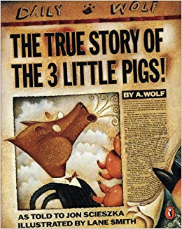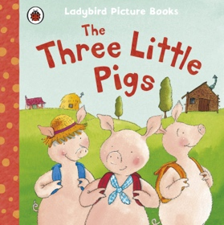

**WOULD YOU OWN A WOLF AS A PET? (Y1)**

**ENGLISH**

**Fiction – Traditional Tale**

Children will explore the traditional tale of The Three Little Pigs. They will consider the story from a different perspective and write their own traditional tale in the view of Mr Wolf.

**Non-Fiction-   
Instructional Writing**

Children will explore the non-fiction book on materials. As architects, we will discuss the best material to trap Mr Wolf. Children will write their own set of instructions that explain how to build a trap of their choice to catch Mr Wolf.

**Poetry – Acrostic Poem**

Children will write their own acrostic poem that focuses on the wolf. Predominantly, children will focus on the figurative language of alliteration.

**SCIENCE – Materials**

In order to build the most effective trap for Mr Wolf, children will explore a range of materials and their properties. Children will adopt the role of an architect and determine the best material to build a trap from. Children must take into consideration the seasons and weather to ensure they build a trap that is effective in all conditions. Children will perform simple experiments to determine whether they will use wood, plastic, glass, metal or rock. Using Venn diagrams and pictograms, children will group everyday materials based upon their physical properties. Together, we will use our five senses to describe the materials using adjectives and highlight any similarities or differences.

**MATHS Link:**

**Measurement** – Measure the **length and height** of materials for structure construction in DT. Children to overcome problems with construction design by deciding whether their material needs to be **longer or shorter**.

**Data Collection –** Children will create their own **pictograms** to record the number of materials in each classification. They will also create **bar graphs** to record the number of days it was sunny or raining etc, throughout a week or **month.**

**Repeated Patterns** – Children will create their own wallpaper design that must feature a repeated, printed pattern.

**Money –** Explore the appearance of **coins and notes** and identify their value in PHSE.

**COMPUTING**The pigs want to share the heroic capturing of Mr Wolf on social media. However, they have never used it before and don’t know about the dangers involved. Children must teach the three little pigs how to keep safe online and decide whether it is a good idea to post about the event on social media.

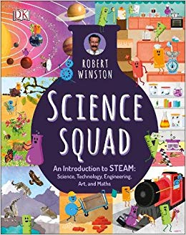

**DT**Having experimented with appropriate materials in science, children will use pictures and words to plan a trap to capture Mr Wolf. Together as architects, children will discuss how the can make a moving element before adding this to their construction to secure Mr Wolf. Children will evaluate their own and peers work.

**Geography**

As architects children must consider when it is the best time to build their trap for Mr Wolf. Children will consider what it is like to be working outside in good and bad weather conditions and determine the best season to begin construction. In order to monitor the weather throughout the months of January, February, March and April, children will make their own weather charts. Using the data they record and daily observations, children will make predictions about what they think the weather will be like in an hour or tomorrow.

**MUSIC**

Children will listen to ‘**The Carnival of the Animals’** by the French composer Camille Saint-Saëns. Together we will explore how the varying tempo, pitch and dynamics represents a different animal and suggest why we think this. Whilst listening to select parts of the song, children will draw the animal they think it represents. Using **The Carnival of the Animals** as a stimulus, children will work in small groups to compose a simple piece that they believe represents Mr Wolf. Children will use their voice, instruments and body to create a range of tempos, dynamics and pitch.

**DISCRETE**

**RE**

**PE**

**PHSE**Remaining in role as an architect, children will explore how they can buy materials. Through P4C style sessions, we will discuss how we can earn money, where we can store it and the things we would like to save it for. Children will explore the different job roles that allow people to earn money, alongside the importance of teamwork and helpful behaviours in the workplace.

**ART – Gaudi - Architecture**

Having considered the exterior of Mr Wolf’s trap, children must now consider the interior and design their own wallpaper. Children will explore the work of the famous Spanish Architect, Antoni Gaudi. Similar to his study of nature, children will identify natural objects in the outside environment that they are inspired by. Children will produce observational drawings of Nature, before using viewfinders on their own work to select a pattern they want to print. Using a selection of natural materials and textiles, children will create their own printing block that features their design. Children will explore how they can produce a repeating pattern within their wallpaper.

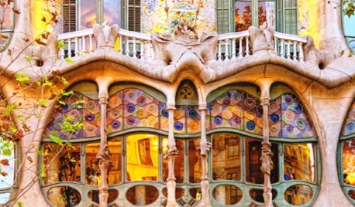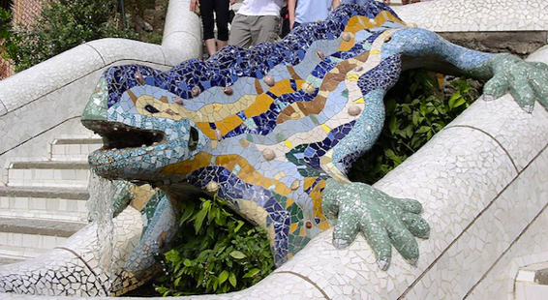

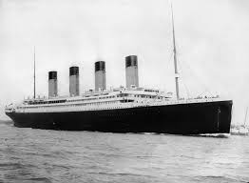

**HISTORY – Travel by water**

Linked to our investigation of materials, children will explore the material that caused the Titanic disaster. We will explore the purpose of the Titanic and compare this to how we go on holiday today. Children will carry out independent investigations of artefacts. They will identify how the toys and clothes children used to take on holiday, compare to their choices today. Together, we will use the vocabulary old, new and a long time ago to discuss the change and purpose of water transport across the Vikings, Captain James Cook and the Titanic. Through role play children will retell the above events of history in chronological order, continually referring to how this compares to their lives now.

**VOCABULARY LIST**

**Wolf:** The largest member of the dog family that travels very long distances.

**Material:** the parts which something is made from. Materials can include: wood, metal, glass, plastic, water and rock.

**Architect:** A person who designs buildings, including how they look and the structure.

**Construction:** The action of building something.

**Season:** Four different times during the year that have different types of weather. The seasons are: spring, summer, autumn and winter.

**Prediction:** a statement about what someone thinks will happen.

**Nature:** Something that is not made by humans, including: plants, animals, oceans and stars.

**Ocean:** A huge body of salt water that covers most of the Earth’s surface. **There is one ocean that is split into five areas, including: Pacific, Atlantic, Indian, Arctic and Antarctic.**

**Ship:** a large vessel that transports lots of people or goods across water for long distances.

**Boat:** a small vessel that travels on water for leisure such as fishing.

**Vessel:** something that is designed to travel on water.

**Disaster:** a sudden event that causes damage or loss of life.

**WOULD YOU OWN A WOLF AS A PET? (Y1)**

**WOULD YOU OWN A WOLF AS A PET? (Y1)**

**Science**

**Materials**

* Can I distinguish between an object and the material from which it is made?
* Can I identify and name a variety of everyday materials, including wood, plastic, glass, metal, water and rock?
* Can I describe the simply physical properties of a variety of everyday materials?
* Can I compare and group together a variety of everyday materials on the basis of their simple physical properties?
* **Can I explain what happen to certain materials when they are heated or cooled?**

**Seasonal Changes**

* Can I observe changes across the four seasons?
* Can I observe and describe weather associated with the seasons and how day length varies?
* **Can I describe how temperatures vary between the seasons?**

**WOULD YOU OWN A WOLF AS A PET? (Y1)**

**Science**

**Observing Closely**

* Can I use senses to help answer questions?
* Can I use some science words to describe what I have seen and measured?
* Can I compare several things?
* Can I use simple equipment to help me make observations?
* **Can I find out by watching, listening, tasting, smelling and touching?**

**Performing Tests**

* Can I say whether things happened as I expected?
* Can I suggest how to find things out?
* Can I use prompts to find things out?
* Can I tell other people what I have done?
* Can I explain what I have learnt?
* **Can I give reasons for my answers using scientific vocabulary?**

**Identifying and Classifying**

* Can I classify materials based upon their appearance?
* Can I ask questions about the classification of materials?
* Can I answer scientific questions about materials?
* Can I sort materials into groups by a given criteria?
* **Can I describe things that are similar and different between materials?**

**Recording Findings**

* Can I show my work using pictures and captions?
* Can I record my finding using standard units?
* Can I put information into a pictogram?
* **Can I use ICT to show my working?**
* **Can I make accurate measurements?**

**WOULD YOU OWN A WOLF AS A PET? (Y1)**

**Geography**

**Geographical Enquiry**

* Can I keep a weather chart?
* Can I answer questions about the weather?
* **Can I make plausible predictions about the weather?**
* **Can I answer questions using a weather chart?**

**WOULD YOU OWN A WOLF AS A PET? (Y1)**

**DT**

**Evaluating processes and products**

* Can I describe how something works?
* Can I talk about my own work and things that other people have done?

**Construction**

* Can I talk with others about how I want to construct my product?
* Can I select appropriate resources and tools for my building project?
* Can I make simple plans before making an object?

**Developing, planning and communicating ideas**

* Can I think of some ideas of my own?
* Can I explain what I want to do?
* Can I use pictures and words to plan?

**Working with tools, equipment, materials and components to make quality products**

* Can I explain what I am making?
* Can I explain which tools I am using?

**Use of materials**

* Can I make a structure/model using different materials?
* Can I make my work tidy?
* Can I make my model stronger if it needs to be?

**Mechanisms**

* Can I make a product which moves?
* Can I cut materials using scissors?
* Can I describe the materials using different words?
* Can I say why I have chosen moving parts?

**WOULD YOU OWN A WOLF AS A PET? (Y1)**

**Art- Architect – Antoni Gaudi**

**Drawing**

* Can I draw lines using two different grades of pencil?
* Can I draw using pencil and crayons?
* Can I draw lines of different shapes and thickness?

**Printing**

* Can I print onto paper and textile?
* Can I print with sponges, vegetables and fruit?
* Can I create a repeating pattern?
* Can I design my own printing block?

**WOULD YOU OWN A WOLF AS A PET? (Y1)**

**Computing**

**E-Safety**

* Can I understand when and why to use passwords?
* Can I agree rules for using the computer?
* Can I understand ‘log on’?
* Do I know how to communicate online?
* Can I understand what personal information is and how to keep it private?
* Do I know what to do if something online makes me feel uncomfortable?
* Do I understand the difference between the online and real world?
* Can I be respectful and polite online?
* Can I agree e-safety rules?
* Can I choose age appropriate material on the internet?

* Can I move my body to the pulse/beat of a song?
* Do I understand **tempo** is the speed of the beat?
* Do I understand sound can be loud and **soft** and this is known as **dynamics**?
* Can I compose a simple rhythm using tuned or untuned percussion instruments and my voice?

**MUSIC**

**WOULD YOU OWN A WOLF AS A PET? (Y1)**

**Historical Enquiry**

* Can I ask and answer questions about old and new objects?
* Can I spot old and new things in a picture?
* Can I answer questions using an artefact/photograph provided?
* Can I give a plausible explanation about what an object was used for in the past?
* **Can I answer questions using a range of artefacts/photographs provided?**
* **Can I find out more about a famous person from the past and carry out some research on him or her?**

**Knowledge and Interpretation**

* Can I begin to identify the main differences between old and new objects?
* Can I identify objects for the past, such as a vinyl record?
* **Can I explain why certain objects were different in the past, e.g., iron, music systems, television?**
* **Can I talk about an important historical event that happened in the past?**
* **Can I explain differences between past and present in my life and that of other children from a different time in history?**

**Chronological Understanding**

* Can they put up to three objects in chronological order (recent history)?
* Can I use words and phrases like: old, new and a long time ago?
* Can I talk about things that happened when I was little?
* Can I recognise that a story that is read to me may have happened a long time ago?
* Do I know that some object belonged to the past?
* Can I explain how I have changed since I was born?
* **Can I put up to five objects/events in chronological order (recent history)?**
* **Can I use words and phrases like: very old, when mummy and daddy were little?**
* **Can I use the words before and after correctly?**
* **Can I say why I think a story was set in the past?**

**HISTORY**

**WOULD YOU OWN A WOLF AS A PET? (Y1)**

**Careers, financial capability and economic wellbeing**

* Do I understand that people get money in different ways?
* Can I make choices about what to buy?
* Do I understand that I may not always be able to have all the things I want?
* Can I suggest a reason why people may want to save money?
* Can I say how it feels to save for something I really want?
* Can I name places where money is stored to keep it safe?
* Do I know some places are safer to store money than others?
* Can I talk about the range of jobs people can do?
* Do I recognise that both men and women are able to do a range of jobs?
* Do I understand that having a job means I can earn money?

**Identity, society and equality**

* Can I identify the different roles of people at home and school?
* Can I solve simple dilemmas about taking responsibility?
* Can I explain why it is important to take responsibility at school and at home?
* Can I recognise different types of helpful and unhelpful behaviour?
* Can I challenge unhelpful behaviour in a positive way?

**PHSE**

**WOULD YOU OWN A WOLF AS A PET? (Y1)**

**WOULD YOU OWN A WOLF AS A PET?** **(Y1)**

**PE  
1st Half Term**

**Cross Curricular Project – Lesson 1**

Each week children will engage in a series of activities that support their learning in other curriculum areas. Year one will channel this PE session as an opportunity to focus on target areas for the week through physical activity. Sessions will include:

* **Mr Wolf Scavenger Hunt**
* Can I work as a team?
* Can I take part in an outdoor, adventurous challenge?
* Can I perform a range of movements that develop my balance, agility and co-ordination?
* Hopping
* Crawling
* Sliding
* Climbing
* Rolling
* Jumping
* **Phonics – Sound trail and grapheme spotter**
* **Number – Number bond bingo**

**Gymnastics – Lesson 2**

* Can I perform basic travelling actions?
* Rolling
* Jumping
* Sliding
* Climbing
* Can I hold body shapes in stillness?
* Can I link shapes through movement?
* Can I create and repeat the phrases beginning, middle and end?
* Can I recognise body tension in myself and others?
* Can I recognise body relaxation in myself and others?
* Can I move with confidence and control?
* Can I space myself out appropriately?
* Can I describe and explain movements myself and others make?

**Dance – Lesson 2**

* Can I change the speed, direction and level of my body?
* Can I repeat and copy body shapes?
* Can I create and repeat the phrases beginning, middle and end?
* Can I move my body in response to stimuli?
* Pictures
* Music
* Objects
* Can I describe and explain my own movements?
* Can I describe and explain the movements of my friends?
* Can I find a safe space to work?

**Games – Lesson 1**

**Ball Skills - Striking and Fielding**

* Can I find a safe space to work?
* Can I change the direction of a ball?
* Can I change the speed of a ball?
* Can I stop a ball?
* Can I strike a ball using a bat with control and accuracy?
* Can I strike a ball with racquet using control and accuracy?
* Can I position my body effectively when aiming?
* Can I move my body to the best place to collect a ball?
* Can I safely intercept my opponent?
* Can I collect a ball with control and accuracy?

**Discrete Subject**

**PE  
2nd Half Term**

**DO OUR ACTIONS SPEAK LOUDER THAN WORDS?**

* Can I identify what makes the Good Samaritan a good person?
* Can I identify the values Christians follow?
* Can I talk about the values I follow?
* Can I explain the meaning behind some Christian values?
* Can I ask and respond to questions about what the Christian community do?
* Can I suggest why some people choose to belong to a community?
* Can I observe and recount different ways of expressing identity and belonging?
* Can I recognise some actions which express a Christian’s way of life?
* Can I talk about similarities between my own faith and Christianity?
* Can I explore questions about belonging?

**RE**

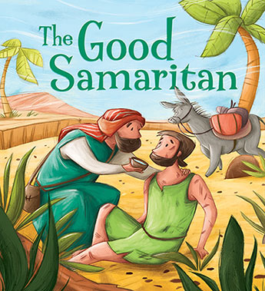

**WHAT DO CHRISTIANS AND JEWS BELIEVE ABOUT CREATION?**

**RE**

* Can I retell the creation story from the bible?
* Can I act out the Bible story of creation using props?
* Can I share the communities from which the stories of creation come from?
* Can I suggest why Christians and Jews tell the same creation story?
* Can I suggest a meaning to the creation story?
* Can I discuss the creation story with my peers?
* Can I ask and respond to questions about the story of creation?
* Can I express my own opinion and ideas about creation through art?
* Can I ask and respond to questions about why the Jewish faith do things differently to Christians?
* Can I appreciate and respond sensitively to similarities between Christianity and Judaism?
* Can I explain how I would feel if I was the first person on the planet and everything was new?
* **Can I find another creation story from a different religion?**