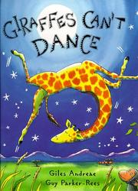

**ENGLISH**

Fiction- Famous Author- Giles Andreae

Children will explore the story of Giraffes Can’t Dance and rewrite the story. They will describe different characters within the story and explore the variety of emotions encountered by the animals.

Non-Fiction- Recount

Children will adopt the role of wildlife rangers. They will explore the depths of the jungle from their jeep and write a recount of their experience that focuses on the animals they see.

Poetry – There’s a Rumble in the Jungle

Children will create their own shape poems using African animals and jungle music as a stimulus. They will use their five senses to compose a descriptive piece.

**ART  
Famous Artists – Eric Carle and Jason Mecier** Children will explore the artwork of Eric Carle and Jason Mecier to produce an illustration for their story that focuses on **collage**. They will combine Jason Mecier’s medium of everyday materials and Eric Carle’s painted paper to produce different shapes and texture. Children will apply art specific vocabulary to evaluate their work.

**DT**Children will go on a cultural journey, visiting the countries where each jungle dance originates from. They will explore the cuisine of Austria, Cuba and Argentina and perform taste tests to identify ingredients that make up a healthy diet. Children will vote for their favourite dish before writing instructions, preparing and weighing ingredients and cooking their own.

**CAN GIRAFFES DANCE? (Y1)**

**SCIENCE – Animals including humans**

Children will learn about a variety of animals including Gerald the giraffe and his Savanna friends. Children will create their own pictograms to record the classification of different types of animals. Together we will use curiosity cubes and feely bags to explore the different diets of certain animals and record the information we retrieve in a Venn diagram. We will discuss what we would like to eat if we lived in the jungle. Children will explore how the structure of their body differs to the structure of Gerald the Giraffe.

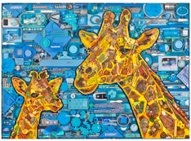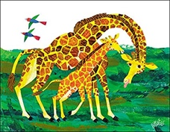

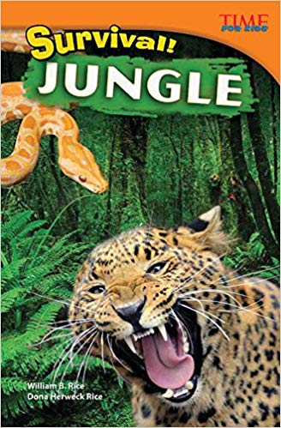

**MATHS Link:**Geometry – Recognise, name, draw and cut out their own 2D shapes for collage work.

Number – Identify and represent numbers using objects.

Measurement – begin to measure weight using scales.

**PE**Children will work together to create their own jungle dances. They will respond to the stimuli of traditional African music and produce a simple movement pattern that represents the movement of African animals.

**COMPUTING**Children will each take it in turns to become photographers and videographers. Using an iPad children will record their peers performing their own jungle dance. Children will explore methods other than a postcard to communicate with the giraffe, including email.

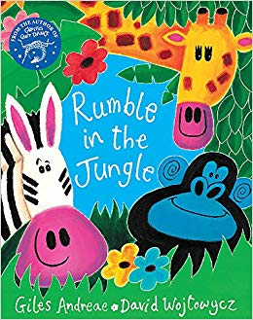

**GEOGRAPHY**

The giraffe and fellow African animals will share postcards with the children about their locality of the African Savanna and their exciting trip to the jungle. The giraffe will provide children an opportunity to ask questions about what they would like to discover about his home. The giraffe and his friends will tell children all about the climate, weather, appropriate clothing and key features of the hot country Tanzania. The giraffe will explain to children that he has never had an opportunity to leave Africa and wants to set them a mission to persuade him to visit their home of Loftus in England. Children will achieve this by sharing what they like and dislike about Loftus through pictures and words. Children will share with the giraffe questions that they would like to ask about Loftus.

**PHSE**Children will explore how the other animals in the story make Gerald the Giraffe feel. They will consider how they would feel if they were Gerald the giraffe and what they could do to help him. Through P4C sessions, children will use a variety of stimuli to explore what makes a person special and how everybody is unique. Stimuli will include the interactive story **Ronald the Rhino**.

**DISCRETE**

**RE**

**MUSIC**

Children will listen to traditional Zulu music originating from the Giraffe’s home of Tanzania. Together we will explore how the music makes us feel and record our responses through drawing. Children will explore moving their bodies in response to the music and along with the beat.

**CAN GIRAFFES DANCE? (Y1)**

**VOCABULARY LIST**

**Jungle:** a thick and overgrown forest with lots of trees, plants and animals.

**The Congo Rainforest:** a very large jungle in Africa where it rains heavily and is hot.

**Africa:** a large continent made up of lots of countries.

**Tanzania:** a country in the continent of Africa.

**Mount Kilimanjaro:** the highest mountain in Africa. It is a dormant volcano.

**Savanna:** a tropical grassland found in hot parts of the world with dry and rainy seasons.

**Giraffe:** the tallest mammal that has a very long neck and legs with brown patches.

**Amphibian:** cold-blooded animals that have a backbone and live on land and in water.

**Mammal:** an animal that has a backbone, gives birth to live young and grows hair or fur.

**Reptile:** an animal that has scales or a shell and usually lays eggs.

**Wildlife Ranger:** a person who works in national parks to protect wildlife. They carry cameras to record any animals that they see.

**CAN GIRAFFES DANCE? (Y1)**

**Science**

**Animals (including Humans)**

* Can I identify and name a variety of common animals including fish, amphibians, reptiles, birds and mammals?
* Can I identify and name a variety of common animals that are carnivores, herbivores and omnivores?
* Can I describe and compare the structure of a variety of common animals?
* Can I identify, name, draw and label the basic parts of the human body and associate body part/sense?
* **Can I name some parts of the body I can’t see?**
* **Can I say why certain animals have particular characteristics?**

**CAN GIRAFFES DANCE? (Y1)**

**Science**

**Observing Closely**

* Can I talk about what I see, touch, smell, hear or taste?
* Can I use simple equipment to help make my observations?

**Performing Tests**

* Can I perform a simple test?
* Can I tell other people what I did?
* Can I predict what might happen?
* Can I use my observations to suggest an answer to a question?
* **Can I give a simple reason for my answer?**

**Identifying and Classifying**

* Can I identify and classify things I observe?
* Can I think of questions to ask about the classification of animals?
* Can I answer scientific questions?
* Can I explain what I have found out?
* **Can I give a simple reason for my answer?**

**Recording Findings**

* Can I show my work using pictures, captions and labels?
* Can I put information into a Venn diagram?
* Can I put information into a pictogram?

**Geography**

# Physical Geography

* Can I describe a locality using words and pictures?
* Can I explain the main features of a hot and cold place?
* Can I name key features associated with the town Loftus?

# Human Geography

* Can I tell something about the people who live in hot and cold places?
* Can I talk about the people who live in hot and cold places?
* Can I explain what I might wear if I lived in a very hot or a very cold place?
* **Can I name different jobs that people living in the area might do?**

**CAN GIRAFFES DANCE? (Y1)**

# Geographical Enquiry

* Can I say what I like about my locality?
* Can I sort things I like and don’t like?
* Can I answer some questions using different resources, such as books, the internet or an atlas?
* Can I think of some good questions to ask about the locality of Africa or Loftus?

**CAN GIRAFFES DANCE? (Y1)**

**DT**

**Developing, planning and communicating ideas**

* Can I think of some ideas of my own?
* Can I explain what I want to do?
* Can I use pictures and words to plan?

**Working with tools, equipment, materials and components to make quality products**

* Can I explain what I am making?
* Can I explain what tools I am using?

**Evaluating processes and products**

* Can I talk about my own work and things that other people have done?

**Cooking and Nutrition**

* Can I prepare a dish from another cuisine?
* Can I discuss what makes a healthy and varied diet?
* Can I use my senses to describe food?
* Do I understand where food comes from?

**CAN GIRAFFES DANCE? (Y1)**

**Art- Famous Artists Eric Carle and Jason Mecier**

* Can I cut and tear paper and card for my collages?
* Can I use a range of materials creatively to make line, shape and pattern?
* Can I gather and sort the materials I will need?
* Can I name the colours I use, including shades?
* Can I name the primary and secondary colours?
* Can I use thick and thin brushes?
* Can I describe what I can see and like in the work of another artist?
* Can I ask sensible questions about a piece of art?
* Can I evaluate my work using the language of art?
* Can I talk about the work of a famous artist?

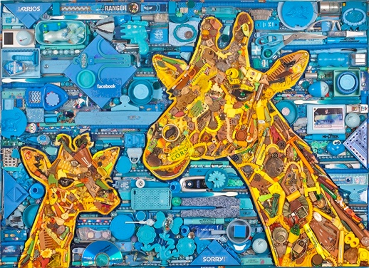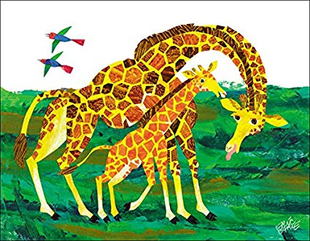

Jason Mecier Artwork

Eric Carle Artwork

**CAN GIRAFFES DANCE? (Y1)**

**Computing**

* Do I recognise that technology can help to collect data?
* Do I understand that information can be stored in different ways?
* Can I use different input devices to store information?
* Do I understand how to use technology?
* Do I understand how to use technology for a range of purposes?
* Can I send an email?

**CAN GIRAFFES DANCE? (Y1)**

**PE**

**1st Half Term**

**OAA – Lesson 1**

* Can I communicate ideas physically and verbally?
* Can I move safely to protect myself and others?
* Can I work cooperatively with my peers?
* Can I think through and plan solutions to problems?
* Can I apply the strategy to solve the problem?

**Dance – Lesson 2**

* Can I change the speed, direction and level of my body?
* Can I repeat and copy body shapes?
* Can I create and repeat the phrases beginning, middle and end?
* Can I move my body in response to stimuli?
* Pictures
* Music
* Objects
* Can I describe and explain my own movements?
* Can I describe and explain the movements of my friends?
* Can I find a safe space to work?

**PE**

**Discrete Subject**

**2nd Half Term**

**Gymnastics – Lesson 1**

* Can I perform basic travelling actions?
* Rolling
* Jumping
* Sliding
* Climbing
* Can I hold body shapes in stillness?
* Can I link shapes through movement?
* Can I create and repeat the phrases beginning, middle and end?
* Can I recognise body tension in myself and others?
* Can I recognise body relaxation in myself and others?
* Can I move with confidence and control?
* Can I space myself out appropriately?
* Can I describe and explain movements myself and others make?

**Games – Lesson 2  
Ball Skills: Net Games**

* Can I move safely and appropriately?
* Can I stop with control when asked to do so?
* Can I change direction safely (avoiding collision)?
* Can I demonstrate control and accuracy when sending a ball?
* Can I demonstrate control and accuracy when receiving a ball?
* Can I aim accurately at the person I am passing the ball to?
* Can I identify team mates and opponents?
* Can I score for my team?

**CAN GIRAFFES DANCE? (Y1)**

**PHSE**

**Identity, society and equality**

* Can I recognise something that makes me special?
* Can I describe the ways I am similar and different to others?
* Do I understand that everyone has something that makes them special?
* Can I identify how my behaviour can affect others?

**Mental health and wellbeing**

* Can I name different feelings?
* Can I recognise that people may feel differently about the same situation?
* Can I identify how different emotions look and feel in the body?
* Can I recognise that some feelings can be stronger than others?
* Can I describe some ways of managing different feelings?
* Do I know when to ask for help?
* Can I discuss what to do when I or someone else feels unhappy?

**CAN GIRAFFES DANCE? (Y1)**

**MUSIC**

* Can I use my voice expressively when singing?
* Can I join in a variety of songs, chants and rhymes?
* Can I listen with concentration to a range of high-quality music?
* Do I understand pulse as the beat of music?
* Can I move my body to the beat of a song?

**WHAT IS IMPORTANT TO YOU?**

**RE**

* Can I identify one item that is special to me and explain why?
* Can I identify a person who is special to me and explain why?
* Can I show someone that I care for them?
* Can I identify what is most important to a Muslim?
* Can I identify what is most important to a Christian?
* Can I recall and name the different practices of Muslims?
* Can I recall and name the different practices of Christians?
* Can I ask thoughtful questions about a place of worship?
* Can I thoughtfully identify similarities between Christianity and Islam?

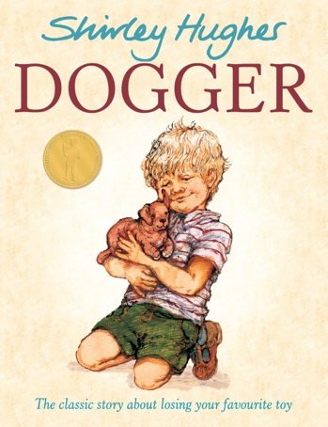

**WHY DO CHRISTIANS CELEBRATE CHRISTMAS?**

**RE**

* Can I discuss what Christmas means to me?
* Can I identify why Christians celebrate Christmas?
* Can I retell in chronological order the story of the nativity?
* Can I act out the story of the nativity?
* Can I recognise a symbol of Christmas?
* Can I explore the meaning of the first star of Bethlem to Christians?
* Can I express my own ideas and opinions in response using art and words?

