Explorer or Pirate? (Y2)
F
COMPUTING
Internet Search - Children will be expected to research and find information using a safe search. All children will be shown how to use safari.
SUBJECTS TAUGHT DISCRETLEY: PE, RE, Music

TRIP
Whitby Museum and the Endeavour Replica – The children will experience first-hand what it was like to be an explorer on a trip.
Maths
There will be weekly opportunities to complete Maths investigations across the curriculum to apply their knowledge and skills.
PSHE
Indoors and Outdoors - safety in the local community

ENGLISH
Autumn 1
Famous Author – Story Writing
Johny Duddle : The Pirates of Scurvy Sands
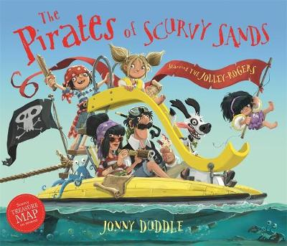
Poetry – The Commotion in the Ocean by Giles Andreae
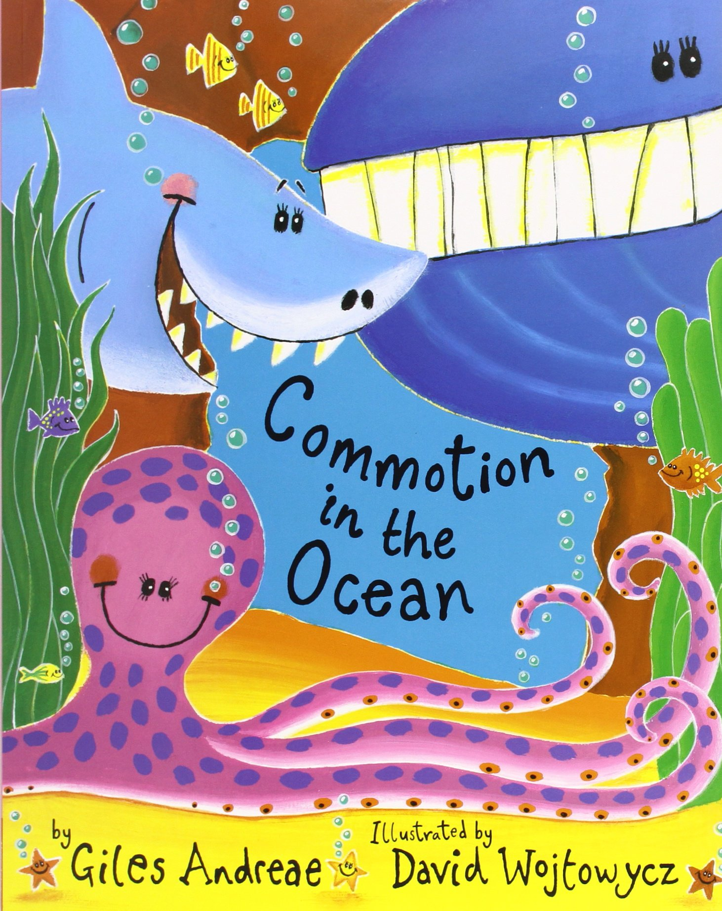
Autumn 2
Non Chronological Reports - Pirates
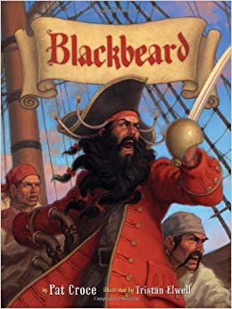

SCIENCE
Living Things and Habitats - Children will look at different living things and habitats and make comparisons between living things that live under the sea and living things that live on land. Also, we will look at different food chains and see why certain living things are suited to the learning environment in which they live.
Plants – Children will study what plants we find in our local area and will make comparisons with plants that grow under the sea.
We will look at different living things, habitats and plants in the local area.

History
Christopher Columbus, Captain Cook and Pirate Blackbeard

All children will be learning about events beyond living memory that are significant nationally or globally.
The children will be looking at the life of Christopher Columbus, Captain Cook and Blackbeard. They will be placing events in chronological order and creating their own timeline of events.
Children will use rich vocabulary when discussing the past and will make comparisons between different explorers and different pirates.

DT
Children to create setting models from the book Commotion in the Ocean. They will plan their designs carefully and evaluate when completed.
Art – George Seurat and Georgia O’Keeffe
Children to sketch portraits of ships and plants. Children will look on famous art work and paint in the style of the artist using pointillism. Sketch books will be introduced and used.

Geography
We will be looking at the route that Christopher Columbus travelled with a focus on continents and oceans. We will compare with Captain Cook and look at the different route he took on his voyages. Children will discuss similarities and differences between the two explorers.
The children will use maps and atlases to locate different places and become confident at talking about different locations across the world. They will look at the different jobs people do in our locality and work together to suggest improvements for the area.

Explorer or Pirate? (Y2)

VOCABULARY LIST
Explorer: An explorer is anyone who travels to places where no one has ever been in order to find out what is there.
Navigator: A navigator is the person whose job is to work out the direction in which the ship should be travelling.
Voyage: A voyage is a journey to a distant place.
Compass: A compass is a tool for finding direction.
Chronological: Chronological is when something is arranged in or according to the order of time.
Territory: A territory is an area of knowledge or interest or a place under the control of someone.
Expedition: An expedition is a journey or excursion undertaken for a specific purpose.
Colony: A colony is a group of people from one country who build a settlement in another territory.
Vessel: A vessel is a craft designed for water transportation.
Crew: A crew is a group of people who operate a ship.
Continent: A continent is a large solid area of land. Continents have different kind of weather, landscapes and population.

Explorer or Pirate? (Y2)

SCIENCE
Living Things and their Habitats
- Can they explore and compare the difference between things that are living, dead, and things that have never been alive?
- Can they identify that most living things live in habitats to which they are suited and describe how different habitats provide for the basic needs of different animals and plants, and how they depend on each other?
- Can they identify and name a variety of plants and animals in their habitats, including microhabitats?
- Can they describe how animals obtain their food from plants and other animals, using the idea of a simple food chain, and identify and name different sources of food?
- Can they describe what animals need to survive and link this to their habitat?

Thinking scientifically
- Ask simple questions and recognise that they can be answered in different ways.
- Observe closely, using simple equipment.
- Identify and classify.
- Use their observations and ideas to suggest answers to questions.
- Gather and record data to help answer questions.
- Give a simple reason for their answers.
- Make accurate measurements.

Plants
- Can they observe and describe how seeds and bulbs grow into mature plants?
- Can they find out and describe how plants need water, light and a suitable temperature to grow and stay healthy?
- Can they describe what plants need to survive and link it to where they are found?

Explorer or Pirate? (Y2)

HISTORY
Chronological Understanding
- Can they use words and phrases like: before I was born, when I was younger?
- Can they use phrases and words like: before, after, past, present, then and now; in their historical learning?
- Can they use the words past and present correctly?
- Can they sequence a set of objects in chronological order and give reasons for their order?
- Can they sequence events about their own life?
- Can they sequence events about the life of a famous person?

Historical Enquiry
- Can they answer questions by using a specific source, such as an information book?
- Can they research the life of someone who used to live in their area using the internet and other sources to find out about them?
- Can they find out something about the past by talking to an older person?
- Can they say at least two ways they can find out about the past, for example using books and the internet?
- Can they explain why eye witness accounts may vary?
- Can they research about a famous event that happens somewhere else in the world and why it has been happening for sometime?

Knowledge and Interpretation
- Can they explain how their local area was different in the past?
- Can they give examples of things that are different in their life from that of their grandparents when they were young?
- Can they explain why some people in the past acted in the way they did?

Explorer or Pirate? (Y2)

GEOGRAPHY
Geographical Understanding
- Can they name the continents of the world and find them in an atlas?
- Can they name the world’s oceans and find them in an atlas?
- Can they locate some of the world’s major rivers and mountain ranges?
- Can they point out the North, South, East and West associated with maps and compass?
- Can they find where they live on a map?
Human Geography
- Can they describe some human features of own locality, such as the jobs people do?
- Can they describe how and why people spoil the area in which they live?
- Can they think how to make an area better?
- Can they explain what facilities a town or village might need?
Physical Geography
- Can they explain what makes a locality special?
- Can they explain some places which are not near the school?

Explorer or Pirate? (Y2)

DT

Design:
- Can they design a purposeful, functional, appealing product for themselves and other users based on design criteria?
Make:
- Can they select from and use a wide range of materials and components including construction materials, textiles and ingredients, according to their characteristics?
Evaluate:
- Can they evaluate their ideas and products against design criteria?

Explorer or Pirate? (Y2)

ART – FAMOUS ARTIST GEORGE SEURAT AND GEORGIA O’KEEFE
Drawing
- Can they use three different grades of pencil in my drawing (4B, 8B, HB)?
- Can they use charcoal, pencil and pastels?
- Can they create different tones using light and dark?
- Can they show patterns and texture in drawings?

Knowledge of Art
- Can they say how other artists have used colour, pattern and shape?
- Can they create a piece of work in response to another artist’s work?

Sketch Books
- Can they keep noted in sketch books as to how they have changed their work?

Explorer or Pirate? (Y2)

COMPUTING
- Using technology purposefully to create, organise, store, manipulate and retrieve digital content
- Can they collect a range of information using technology?
- Can they represent data in different ways?
- Can they create a range of digital content, save, retrieve and evaluate it?
- Can they understand the file system on the school network and on online space?
- Can they retrieve information from the internet?
- Can they use a safe search?
- Can they select appropriate tools for the task?

Explorer or Pirate? (Y2)

RE

- Can they recall and name different beliefs and practices, including festivals, worship, rituals and ways of life?
- Can they explain the meanings behind different beliefs and practices?
- Can they appreciate some similarities between communities?
- Can they ask and respond to questions about what communities do?
- Can they notice and respond sensitively to some similarities between different religions and worldviews?
- Can they explore questions about belonging, meaning and truth?

Explorer or Pirate? (Y2)

PSHE
Indoors and Outdoors
- Can they discuss simple rules for keeping safe indoors, including online?
- Can they describe what to do if there is an emergency?
- Can they take responsibility for their own safety?
- Can they talk about rules to keep safe?
- Can they assess whether a situation is safe or unsafe?
- Can they explain the important of telling someone why they are going out playing?
- Can they identify hazards in relation to road safety?
- Can they explain how to cross the road safely?
- Can they explain the rules in relation to road safety?

Discrete Subject

PE
Swimming

Gymnastics
- Can they roll forward?
- Can they balance?
- Can they link movements to create sequences?
- Can they travel backwards, forwards and to the side?
- Can they balance on different spots?
- Can they control their body and be still?

Ball Skills: Invasion games
- Can they kick small and large balls?
- Can they roll small and large balls?
- Can they bounce small and large balls?
- Can they work with a partner?
- Can they send and receive a ball?
- Can they find and use a space?
- Can they communicate and use simple tactics?
- Can they gather and intercept a ball?

Discrete Subject

Music
Hands, Feet, Heart
Listen & Appraise - begin to recognise styles, ﬁnd the pulse, recognise instruments, listen, and discuss other dimensions of music. Musical Activities - a new activity is added until Step 4:
● Games - continue to internalise, understand, feel, and know how the dimensions of music work together. Focus on Warm-up Games. Pulse, rhythm, pitch, tempo, dynamics.
● Singing - continue to sing, learn about singing and vocal health. Continue to learn about working in a group/band/ensemble.
● Playing - Continue to play a classroom instrument in a group/band/ensemble.
● Improvisation - option after Step 3 - continue to explore and create your own responses, melodies and rhythms.
● Composition - option after Step 4 - continue to create your own responses, melodies and rhythms and record them in some way.
Perform/Share - Continue to work together in a group/band/ensemble and perform to each other and an audience. Discuss/respect/improve your work together.

