Background To Concrete, Pictorial and Abstract (CPA)
Children and adults can find maths difficult because it is abstract. The CPA approach helps children learn new ideas and build on their existing knowledge by introducing abstract concepts in a more familiar and tangible way. The approach is firmly embedded in Inspire maths teaching.
Concrete is the “doing” stage, using concrete objects to model problems. Instead of the traditional method of maths teaching, where a teacher demonstrates how to solve a problem, the CPA approach brings concepts to life by allowing children to experience and handle physical objects themselves. Every new abstract concept is learned first with a “concrete” or physical experience.
For example, if a problem is about adding up four baskets of fruit , the children might first handle actual fruit before progressing to handling counters or cubes which are used to represent the fruit.
Pictorial
Pictorial is the “seeing” stage, using representations of the objects to model problems. This stage encourages children to make a mental connection between the physical object and abstract levels of understanding by drawing or looking at pictures, circles, diagrams or models which represent the objects in the problem.
Building or drawing a model makes it easier for children to grasp concepts they traditionally find more difficult, such as fractions, as it helps them visualise the problem and make it more accessible.
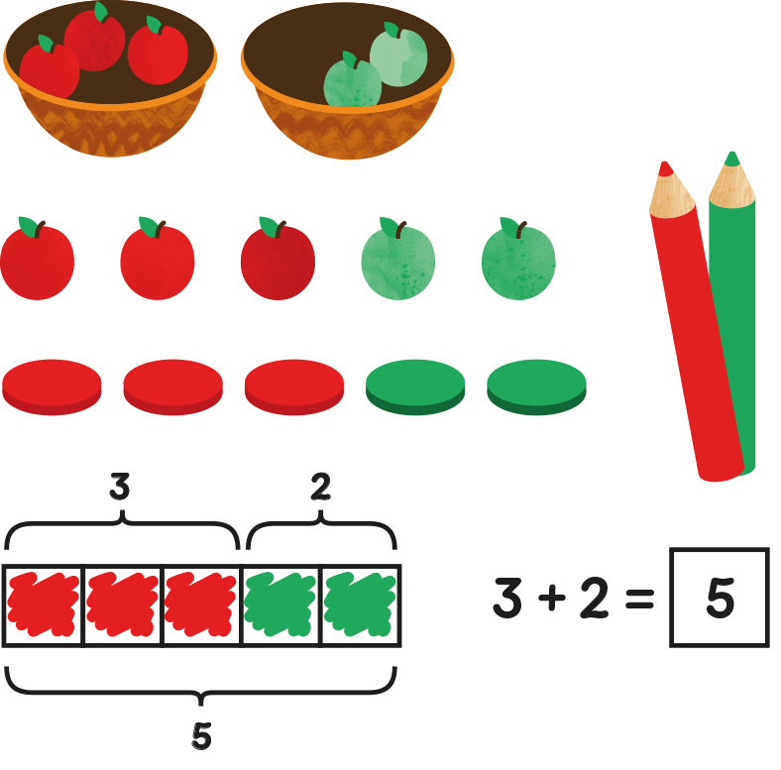
Abstract
Abstract is the “symbolic” stage, where children are able to use abstract symbols to model problems.
Only once a child has demonstrated that they have a solid understanding of the “concrete” and “pictorial” representations of the problem, can the teacher introduce the more “abstract” concept, such as mathematical symbols. Children are introduced to the concept at a symbolic level, using only numbers, notation, and mathematical symbols, for example +, –, x, / to indicate addition, multiplication, or division.
Although we’ve presented CPA as three distinct stages, our teachers will go back and forth between each representation to reinforce concepts.
Our approach encourages teachers to vary the apparatus the children use in class, for example, one day they might use counters, another day they might use a ten frame. Likewise, children are encouraged to represent the day’s maths problem in a variety of ways, for example, drawing an array, a number bond diagram or a bar model. By systematically varying the apparatus and methods they use to solve a problem, we help children to make quicker mental connections between the concrete, pictorial and abstract phases.
When teaching young children their numbers, counters and multi-link cubes are more commonly used in the UK. But concrete apparatus is often put away by the time children reach KS2 because teachers consider their use too childish or distracting. By removing concrete materials from the children, they are being exposed to abstract concepts too early and are missing out on the opportunity to build the conceptual mathematical understanding which they need to take them through their education. This does not happen at Handale Primary School as we believe the use of concrete resources is a must in our children’s learning.

